**Exercise 3: Stored Procedures**

**Scenario 1:**

The bank needs to process monthly interest for all savings accounts.

**PL/SQL Query:**

CREATE OR REPLACE PROCEDURE ProcessMonthlyInterest IS

BEGIN

FOR rec IN (

SELECT account_id, balance

FROM accounts

WHERE LOWER(account_type) = 'savings'

) LOOP

UPDATE accounts

SET balance = balance + (rec.balance * 0.01)

WHERE account_id = rec.account_id;

DBMS_OUTPUT.PUT_LINE('Interest added to account ID: ' || rec.account_id);

END LOOP;

END;

/

**Script Output:**

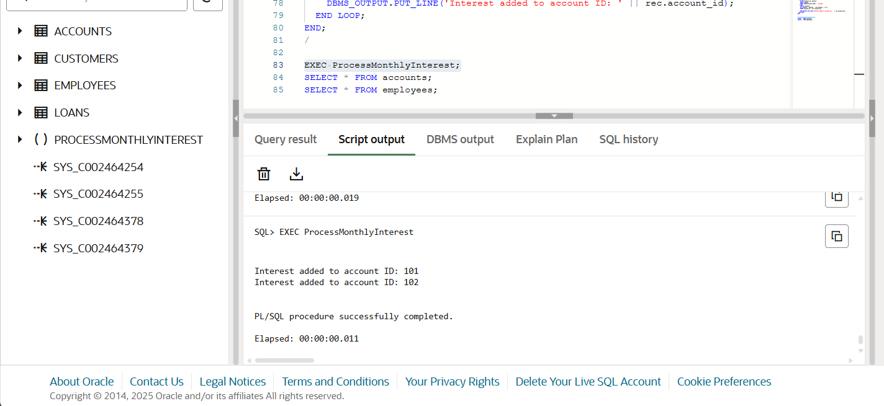

**Scenario 2:**

The bank wants to implement a bonus scheme for employees based on their performance**.**

**PL/SQL Query:**

CREATE OR REPLACE PROCEDURE UpdateEmployeeBonus (

dept_id IN NUMBER,

bonus_percent IN NUMBER

) IS

BEGIN

FOR rec IN (

SELECT employee_id, salary

FROM employees

WHERE department_id = dept_id

) LOOP

UPDATE employees

SET salary = salary + (rec.salary * bonus_percent / 100)

WHERE employee_id = rec.employee_id;

DBMS_OUTPUT.PUT_LINE('Bonus applied to Employee ID: ' || rec.employee_id);

END LOOP;

END;

/

**Script Output:**

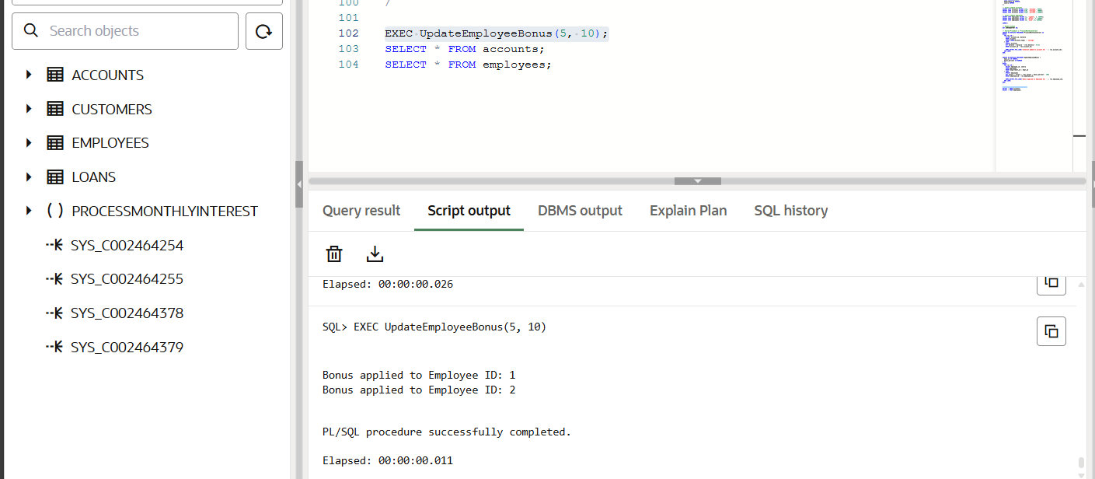

**Scenario 3:**

Customers should be able to transfer funds between their accounts.

**PL/SQL Query:**

CREATE OR REPLACE PROCEDURE TransferFunds (

from_account_id IN NUMBER,

to_account_id IN NUMBER,

amount IN NUMBER

) IS

from_balance NUMBER;

BEGIN

-- Get source account balance

SELECT balance INTO from_balance

FROM accounts

WHERE account_id = from_account_id;

IF from_balance < amount THEN

DBMS_OUTPUT.PUT_LINE('Transfer failed: Insufficient funds.');

ELSE

-- Deduct from source

UPDATE accounts

SET balance = balance - amount

WHERE account_id = from_account_id;

-- Add to destination

UPDATE accounts

SET balance = balance + amount

WHERE account_id = to_account_id;

DBMS_OUTPUT.PUT_LINE('Transfer successful from Account ' || from_account_id || ' to ' || to_account_id);

END IF;

EXCEPTION

WHEN NO_DATA_FOUND THEN

DBMS_OUTPUT.PUT_LINE('One or both account IDs do not exist.');

END;

/

**Script Output:  
